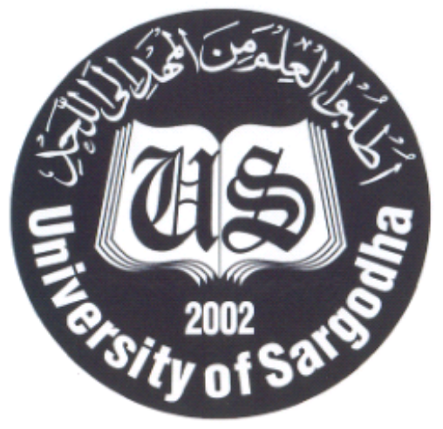 |  | DEPARTMENT OF URDU & ORIENTAL LANGUAGES
 |  | UNIVERSITY OF SARGODHA, SARGODHA
Applications for the visiting faculty for Fall Semester 2021 are invited from Pakistani Nationals on the prescribed form, which can be downloaded from University website: www.su.edu.pk
Sr. # | Name of Post |  | Number of Posts | Eligibility Criteria
1. | Lecturer/ A.P Punjabi (Visiting Basis) |  | As per requirement | As per HEC eligibility criteria.
GENERAL INFORMATION
- The Prescribed application form can be downloaded from University of Sargodha website i.e. www.su.edu.pk.
- Candidates are required to submit one copy of application alongwith complete C.V and attested copies of testimonials.
- Passport size photographs should be affixed on application form.
- Applications received after the last date will not be entertained; even though posted before the last date.
- Incomplete applications shall also not be entertained.
- Last date for submit of applications is 19.11.2021.
- Demonstration / Interviews for the posts will be conducted on 23.11.2021 (at 11:00 am) in the office of the Chairman, Department of Urdu & Oriental Languages, UOS.
- The University reserves the right not to consider any application or fill any post without giving any reason.
- No TA/DA will be admissible.

Chairman
Department of Urdu & Oriental Languages
University of Sargodha, Sargodha.
Ph. # 048-9230823 , website www.su.edu.pk

